joins

Frameworks, SEL and YOU!

A Parent’s Guide to Social-Emotional Learning
You may have recently heard your son or daughter talking about Frameworks, or School-Connect® and you may be wondering what that is and who we are. We are a not-for-profit organization whose mission is to teach youth to manage their emotions, develop healthy relationships, and make good decisions for academic, career, and personal success. How is this accomplished? Through social and emotional learning. We teach a core set of social and emotional attitudes, values, and skills that help children, teens, and adults more effectively handle life challenges to succeed in academic, social, and professional environments. In short, we teach youth and adults to manage their emotions so that those emotions do not manage them.  Growing research shows that without strong social and emotional learning (SEL), we are not equipped with all the tools and skills we each need to succeed in life. Although success is measured differently for youth and adults, research shows that youth who receive SEL education experience less emotional stress, fewer conduct problems, have higher test scores and grades, and more pro-social behaviors than youth who do not receive SEL education (Peyton, et al., 2008).  At Frameworks, we deliver our programs through partnerships with schools and other youth-serving nonprofits. Our goal is to develop healthy schools and organizations that support the social and emotional development of youth. We do this by implementing our curriculum through direct service or training teachers and staff in these organizations to deliver the curriculum. |  |  |  | The Five Competencies of SEL  With brief descriptions  *Self-Awareness: Recognizing one’s emotions and values as well as one’s strengths and challenges  *Self-Management: Managing emotions and behaviors to achieve one’s goals  *Social Awareness: Showing understanding and empathy for others  *Relationship Skills: Forming positive relationships, working in teams, dealing effectively with conflict  *Responsible Decision-Making: Making ethical, constructive choices about personal and social behavior
“When schools commit to promoting students’ social-emotional learning, they become positioned to engage all education stakeholders and create a safe, equitable, and engaging school climate, so each student acquires and enhances the knowledge, skills, and dispositions they need for interpersonal and life success” (cfchildren.org).

You Can Get Involved!

Parent-Friendly Resources
We are excited to have Community Building Sessions (CBS) and School-Connect® implemented this year at Cristo Rey! School-Connect® is a high school research-based program that targets students in grades 9-12 and one of its major goals is to increase students’ sense of belonging and connectedness to school. There are 60 lessons designed to improve high school students’ social, emotional, and academic skills and strengthen relationships between students and teachers.  http://casel.org/parent-resources/  www.edutopia.org/SEL-parents-resources  http://myframeworks.org/for-parents/ |  |  | Students are also on the receiving end of more stimuli and information than ever before and yet they often have difficulty finding reliable resources and advocating for themselves. Plainly speaking, our students are required to digest a lot of information, and an involved parent or guardian can make the world of a difference!  Below are some parent-friendly websites that range from blogs and articles to reports and data to helpful videos.  www.parenttoolkit.com/topics/social-and-emotional  http://www.gettingsmart.com/2015/04/the-power-of-parenting-with-social-and-emotional-learning/  *For more specific resources, or questions please contact Megan Simmons, High School Team Lead at msimmons@myframeworks.org
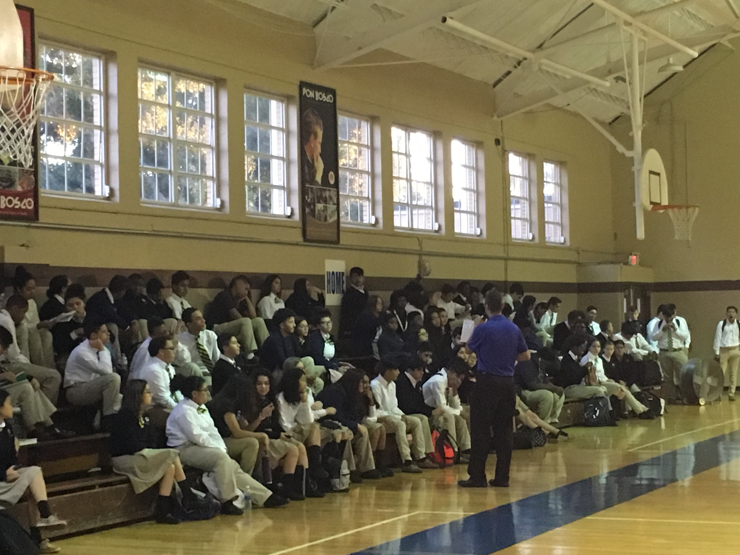
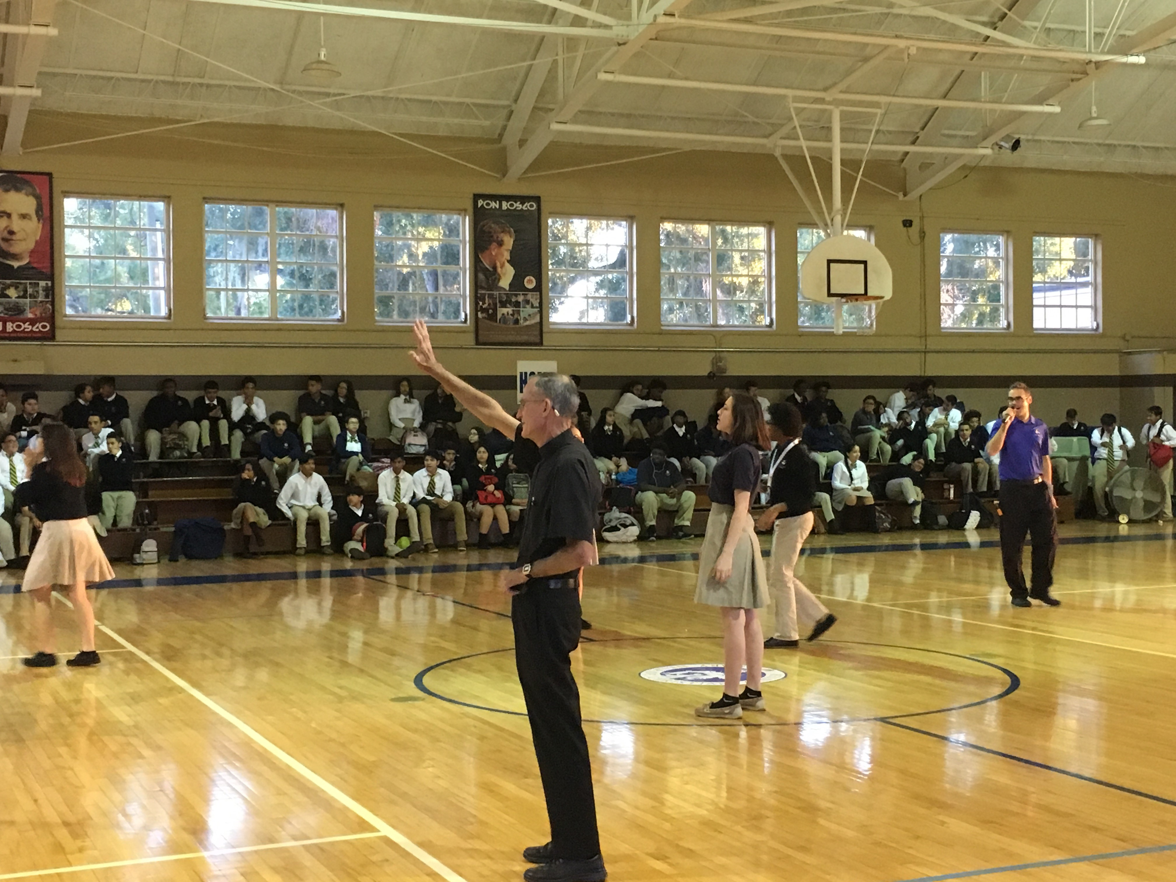
From “Ready to Lead”, a report for CASEL, casel.org
“…students who receive high-quality SEL in the classroom display better academic performance, improved attitudes and behaviors, greater motivation to learn, deeper connection to school, and improved relationships with peers, as well as fewer delinquent acts, conduct referrals, and reduced emotional distress, including fewer reports of student depression, anxiety, stress and social withdrawal” (Sklad, Diekstra, Ritter, Ben, & Graventeijn, 2012; Wigelsworth, Qualter, & Humphrey, 2017).

